ZZSC9020 – Week 1 Project Meeting Agenda (with Wei Tian)
Project: Electricity Demand Forecasting (NSW) by Group A
Meeting Date: March 17, 2026
Time: 8pm – 9pm
Location / Platform: MS Teams Meeting
Attendees: Wei Tian, Brendan, Daniel, Kam, Kelvin
1. Reporting Status of Administrative Setups and GitHub Repository Setup
2. Reporting Project Scope and Research Question Agreed
3. Reporting Current Progress – Data Pre-processing and Preliminary Literature Review
4. Reporting Data and Variables we Agreed
5. Reporting Methods and Modelling Plan
6. Reporting Software Agreement
A. Group Meeting Software
B. Collaborative Work Management
C. Data Analysis Software
D. Reproducible Report Writing
E. Oral Presentation Software
F. Additional Software
7. Reporting Team Roles and Responsibilities
8. Reporting Timeline and Milestones
9. Questions:
a) can we use teams recording to present the paper?
b) can we use jupyter notebook or LaTeX for reporting writing?
10. Reporting Next Steps

ZZSC9020 – Week 1 Meeting Minutes
Project: Electricity Demand Forecasting (NSW) by Group A
Meeting Date: March 17, 2026
Time: 8pm – 9pm
Location / Platform: MS Teams Meeting
Attendees: Wei Tian, Brendan, Daniel, Kam, Kelvin
1. Administrative Items
Communication platform agreed: MS Teams
Meeting frequency: At least once with group members per week + another with lecturer
Next meeting time: Next meeting: 7:30pm on March 19, 2026 (Thursday)
GitHub:
Repository name: capstone_project_GroupA (created)
Access granted to lecturers: ☑ Yes / ☐ No
Folder structure agreed: ☑ Yes / ☐ No (using default structure)
Commit frequency: Flexible, could be anytime we have made changes. At least once weekly.
Version control rules: Everyone should be able to just push changes
2. Project Scope and Research Question
Research problem summary: Can the PatchTST transformer model produce more accurate long-horizon forecasts of NSW electricity demand compared with SARIMAX and LSTM models?
Importance / motivation:
- Addressing the Operational Gap: Improved long-horizon forecasting allows for proactive grid management, reducing system instability and the risk of service disruptions during peak demand periods.
- Economic Impact: Enhancing predictive accuracy leads to greater generation efficiency and direct profitability for energy providers.
- Strategic Governance: Advanced forecasting supports national energy security by effectively integrating volatile renewable sources with traditional energy supplies.
Wei raised the question on how 55 day forecasting horizon was chosen. Team will discuss this in the coming meeting and decide how to justify and/or adjust it.

3. Literature Review
Aim: using 3 different models to perform forecast and compare to the actual forecast and see if a better model can be chosen to improve forecast.
Some key papers selected and we will look at some more.
Section responsibilities:
- Classical models: Brendan and Daniel
- LSTM: Brendan and Daniel
- Transformers / PatchTST: Kam and Kelvin
Action this week: Review relevant key papers and prepare for literature review to support the key research question.

4. Data and Variables
Datasets confirmed: using the 3 datasets provided from GitHub
Variables to include: Electricity demand, Temperature and Time-based features
Data cleaning responsibilities: Kam (already drafted in EDA)
Data pre-processing steps: Kam (already performed and shared in GitHub)
Data split for train/validation/test: 60/20/20

5. Methods and Modelling Plan
Models confirmed:
☑ SARIMAX – Lead: Brendan and Daniel
☑ LSTM – Lead: Brendan and Daniel
☑ PatchTST – Lead: Kam and Kelvin
Forecasting design: 55-day horizon (justification to be included in literature review)
Evaluation metrics: RMSE and MAE (justification to be included in literature review)
Software/libraries: Python, with libraries: pandas, statsmodels, PyTorch/TensorFlow etc
6. Assessment 1B – Software Agreement
 | Software/Tools/Platform | Justification
A. Meeting Software | MS Teams | (to be confirmed in March 19 meeting)
B. Collaboration Tools | GitHub | (to be confirmed in March 19 meeting)
C. Data Analysis Software | Python | (to be confirmed in March 19 meeting)
D. Reproducible Report Writing | Jupyter Notebook + LaTeX + Word | (to be confirmed in March 19 meeting)
E. Oral Presentation Software | Powerpoint + Recording Software (TBD in next meeting) | (to be confirmed in March 19 meeting)
F. Additional Software
7. Roles and Responsibilities
 | Responsibility | Skills
Brendan | Research consultant / lead  Model analysis of SARIMAX + LSTM | Research experience  Data analysis experience
Daniel | Presentation/Communication Lead  Model analysis of SARIMAX + LSTM | Teaching experience  Data analysis experience
Kam | Project Manager  Presentation/Communication Lead³  Model lead of PatchTST + Comparison | Teaching experience  Data analysis experience
Kelvin | Logistics coordinator  Model lead of PatchTST + Comparison | Data analysis experience

8. Timeline and Milestones
Week | Activities | Milestone
Week 1 | - Form project team,  - Discuss project scope and research question,  - Conduct preliminary literature review,  - Finalize project plan,  - Confirm approaches, dataset and variables | Project plan finalized
Week 2 | - Data cleaning,  - Preprocessing,  - Exploratory data analysis,  - Prepare implementation checklist | Implementation checklist prepared
Week 3 | - Implement and evaluate SARIMAX baseline model  - Implement LSTM model and tune hyperparameters  - Implement PatchTST model and draft comparison of model performance  - Prepare individual reflection portfolio | 1. Model set up with results  2. Individual reflection portfolio completed
Week 4
Week 5 | - Conduct forecasting experiments,  - Draft report, and  - Prepare presentation | Results and implications agreed
Week 6 | Finalize report and prepare presentation | Report finalized
Week 7 | Finalize video presentation | Videos finalized
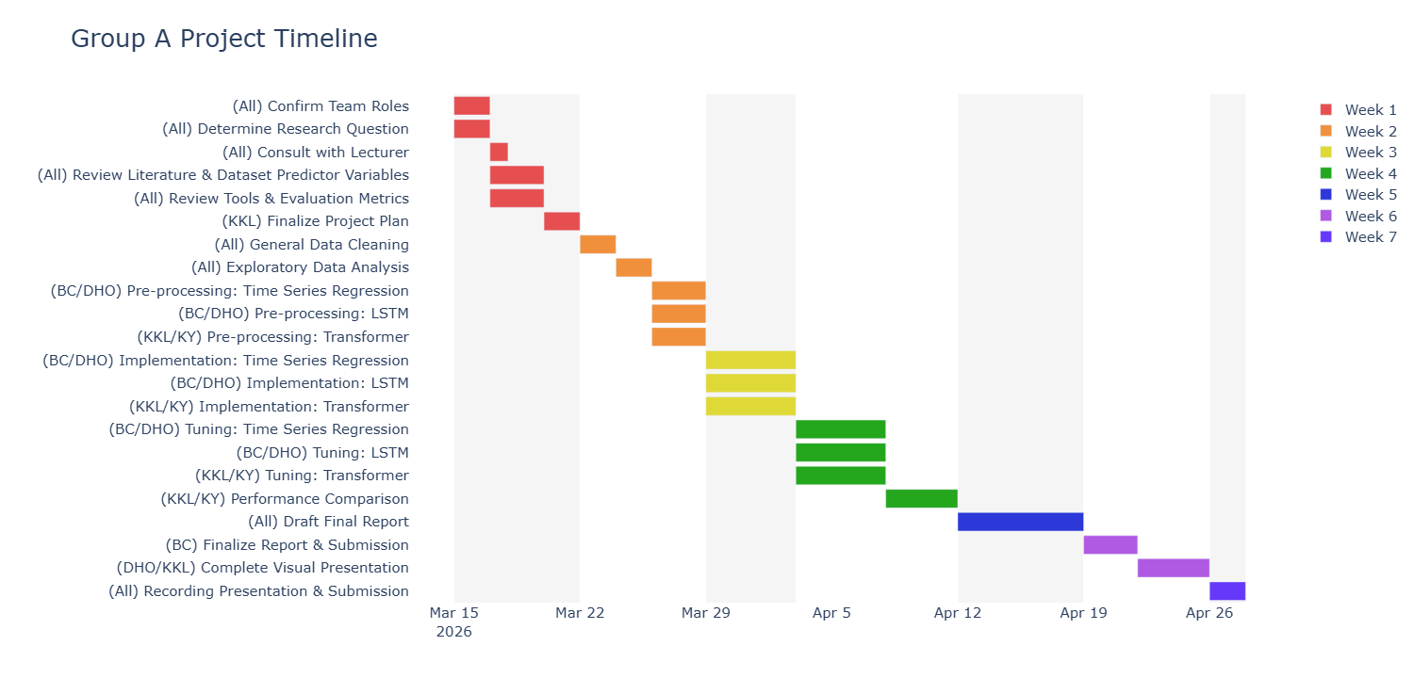
Internal deadlines agreed:
- deliverables to be ready and sent out before 10am on each internal meeting day on Fridays
- Week 1,2 deliverables: project plan and implementation checklist will be drafted by end of March 20, 2026 (Wed).
9. Action Items & Next Steps
Brendan: Conduct preliminary literature review^{(#)}
Daniel: Conduct preliminary literature review^{(#)}
Kam: Conduct preliminary literature review^{(#)}, finalize draft project plan according to the agreed items before lecturer review
Kelvin: Conduct preliminary literature review^{(#)} + GANTT Chart + Book Lecturer Review
(#) Find a paper we think is useful, draft a brief summary of it and think about how it relates to our research question. Pull together in the next meeting to get bigger picture.

11. Next Meeting
Meeting Date (internal): March 19, 2026 (Thursday) starts 7:30pm MS Teams
Meeting Date (with lecturers): Need basis, TBC
Appendix:
Draft Project Plan:

Research consultant / lead: driving research direction and scrutinize results (e.g. Train/Validate/Test split, epochs, other hyperparameters), drive direction of research report
Presentation/Communication lead: driving direction and main message of video presentation to meet the objective of delivering the message on how data science approach is applied to solve daily life problem in simple language
Logistics coordinator: Driving discussion, communicate with lecturers, etc

